MINI EAGLE CLAW
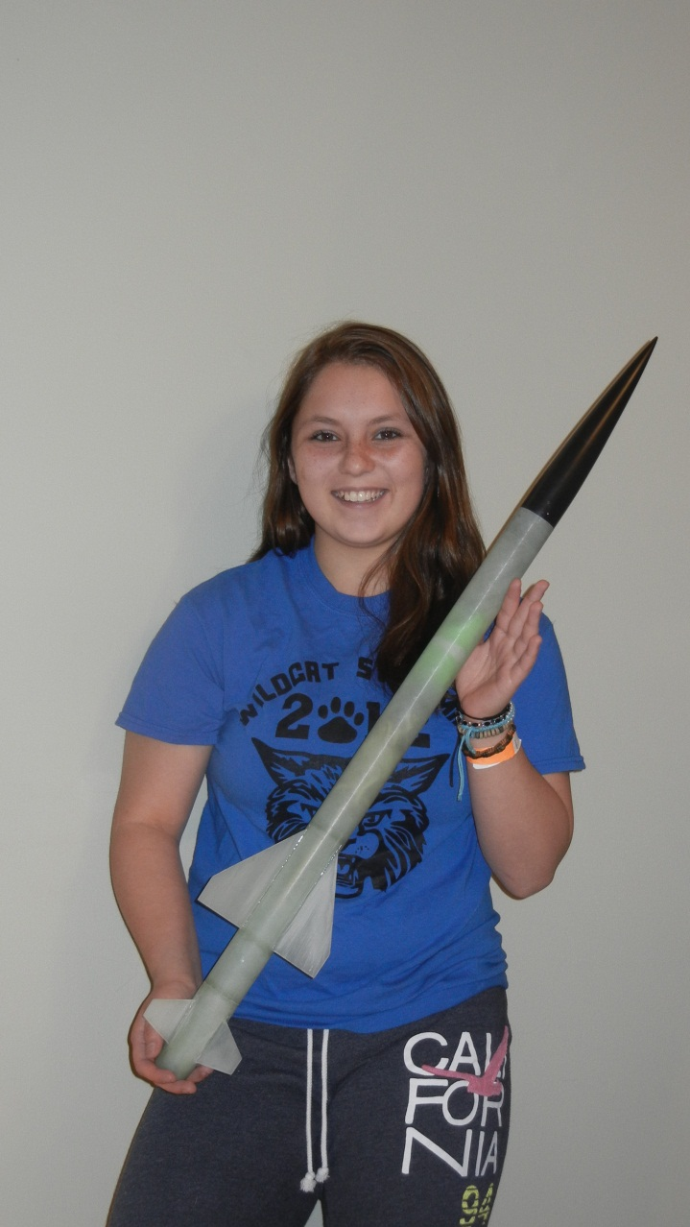

Parts list

- (1) Composite nose cone
- (1) Slotted Body Tube
- (1) Motor Mount Tube
- (1) Slotted Boat Tail
- (2) Motor Mount Centering Rings
- (1) Boat Tail Coupler Ring
- (1) Parachute
- (1) Shock cord
- (1) Upper fin set (3 fins)
- (1) Lower fin set (3 fins)

Remove all parts form bag and make sure you are not missing anything.

Sand all pieces and test for smooth fit. Make sure to sand all pieces that will be glued together.

Wash off all fiberglass dust and any dirt from pieces.

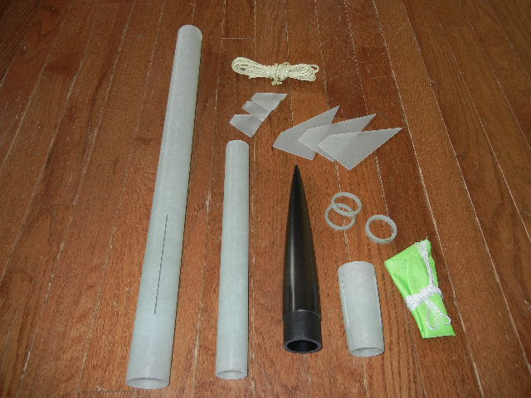

Before you start building, pay special attention to the 3 rings. They may all look the same, but they are not.
2 of them are the same size and the other is wider. The wide one is a COUPLER and not a centering ring. This one will be used for the boat tail.
This is the first WildMan Mini Kit to use this unique boat tail design.
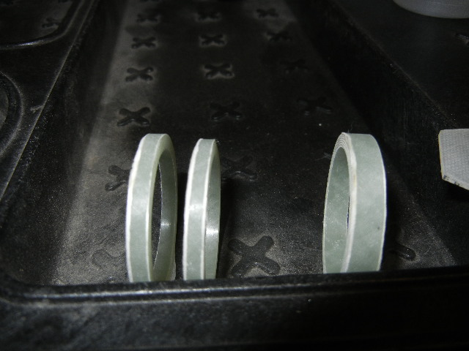
These step by step instructions will help you to easily assemble this rocket. Pay attention to the small details. This one is a little bit different than the others.

Slide the coupler centering ring (the fatter one) onto the motor mount DO NOT GLUE AT THIS TIME.
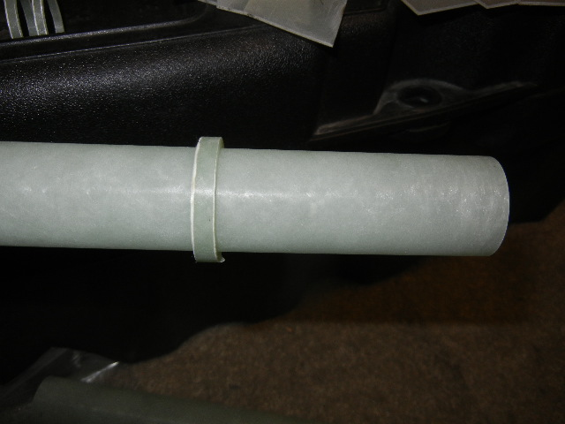

Test fit the boat tail onto the motor mount. Make sure it slides all the way through the end of the boat tail.
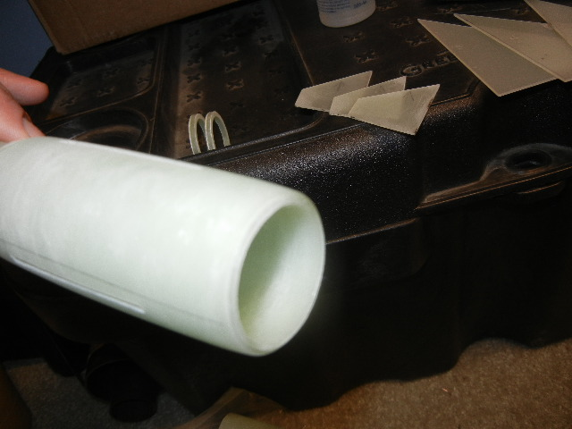

Remove the boat tail and spread a liberal amount of epoxy to the aft end of the motor mount tube.
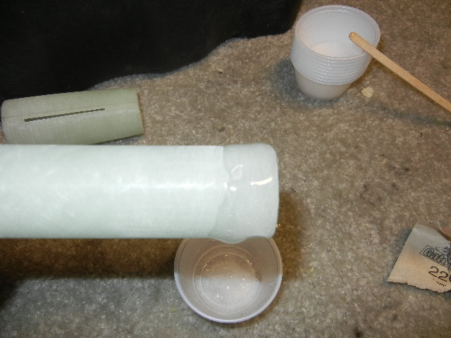

Slide the Boat tail onto the motor mount and keep it aligned with the coupler centering ring. Slide the ring in half way to center
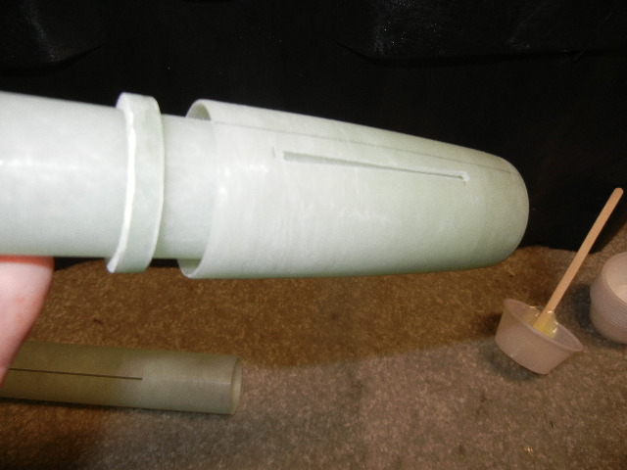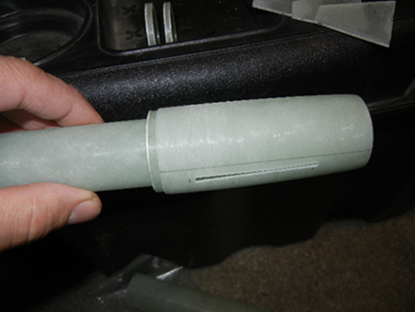
Epoxy the coupler ring in place. Half the ring should be inside the boat tail and half should be exposed.
Stand the motor mount assembly upright while the epoxy cures. You want to keep the epoxy from dripping onto the motor mount tube near the fin location.
5 min west systems epoxy was used for this step.
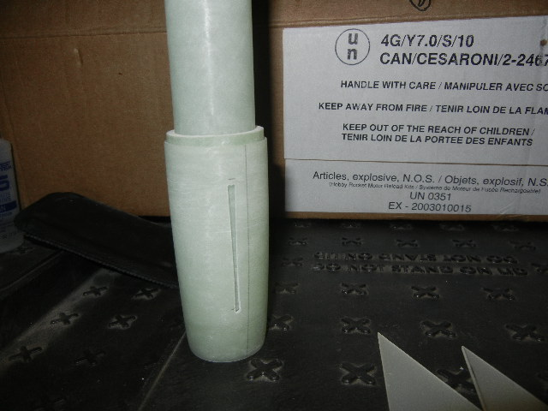

When the boat tail has cured, remove any epoxy that may have ozzed out of the bottom. Quick sanding with some 100 grit paper should take care of that.
Also make sure there is no epoxy build up on the coupler. Sand as needed.

Find the 3 lower fin set and pay close attention to the root cord edge. I marked the fins with a pencil to prevent them from being installed wrong.
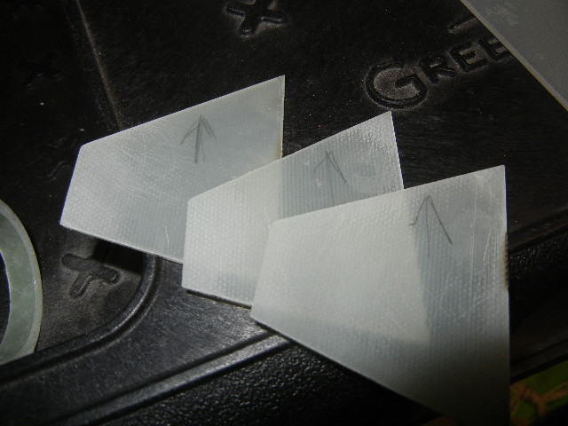
Using a method that works best for you, epoxy the lower fins in place. You do not need to inject internal fillets. Make sure you get a nice bead of epoxy along the entire root cord and good contact with the motor mount.
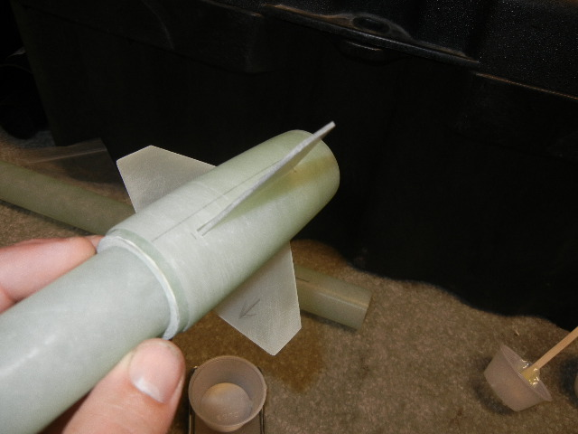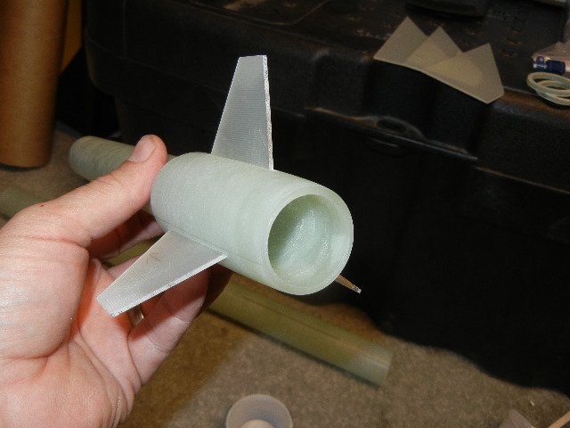

Now you will need to mark the motor mount tube for the centering ring locations.
Place the body tube next to the motor mount assembly/boat tail. Make sure the body tube is up against the boat tail.
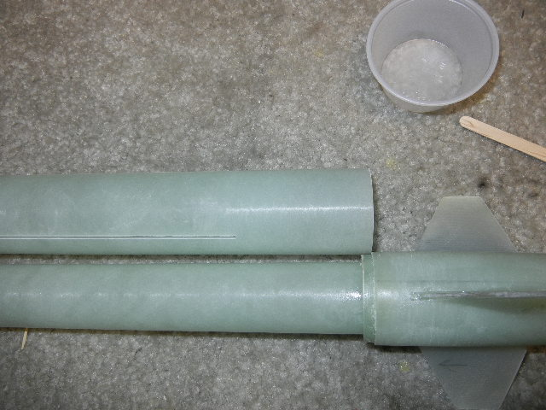
With a pencil, draw 2 lines on the motor mount to mark the fin locations. The centering rings will be glued at these marked points.
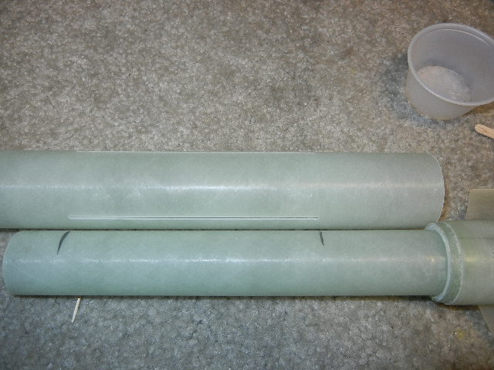
With a file or Dremel tool, make a notch on the inside edge of one of the two centering rings. This will be to pass the shock cord through.
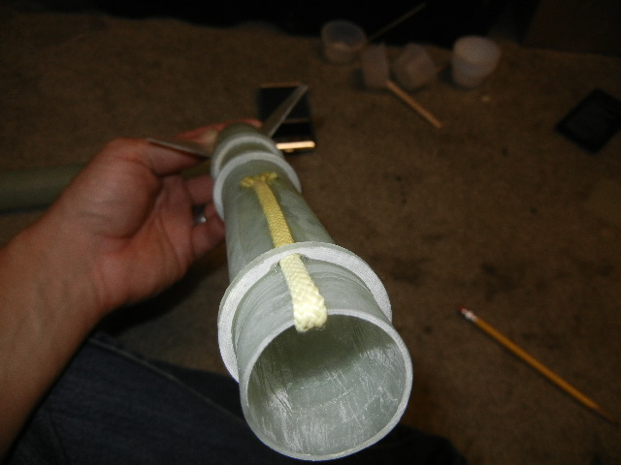
Test fit the cord and rings onto the motor mount.

Next, epoxy the two centering rings onto the motor mount. Pass the shock cord through the top ring (notched). Make sure cord is in between 2 fins. Keep the rings aligned with the marks made earlier. Test fit to make sure the upper fins fit smooth while the epoxy is curing (do not epoxy the fins yet).
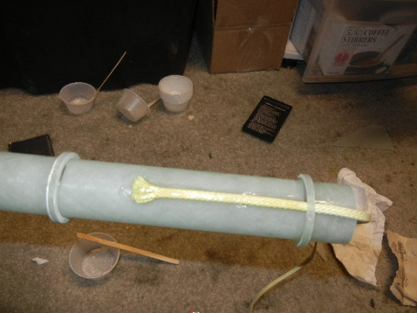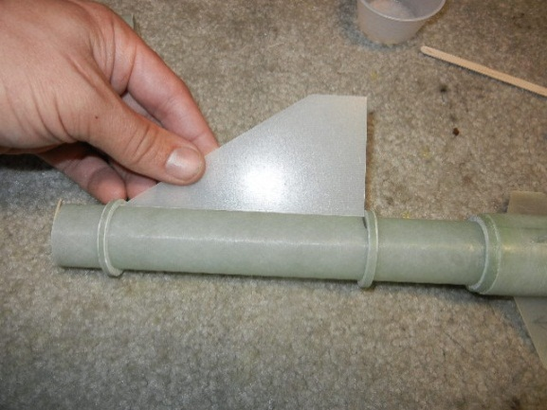
Once the epoxy has cured, finish off the assembly by encapsulating the shock cord in epoxy. Be careful not to allow the epoxy to drip all over the motor mount tube. You must keep epoxy from dripping down motor tube. Keep in mind the placement of the upper fins.
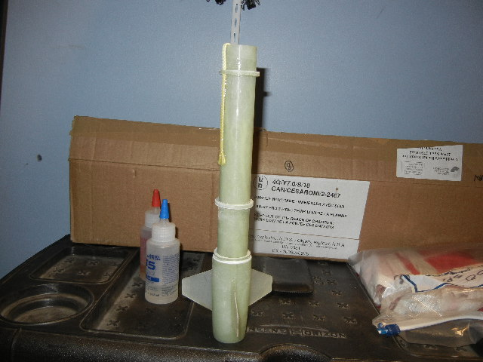

Slide the body tube onto the boat tail coupler and test fit all 3 fins.
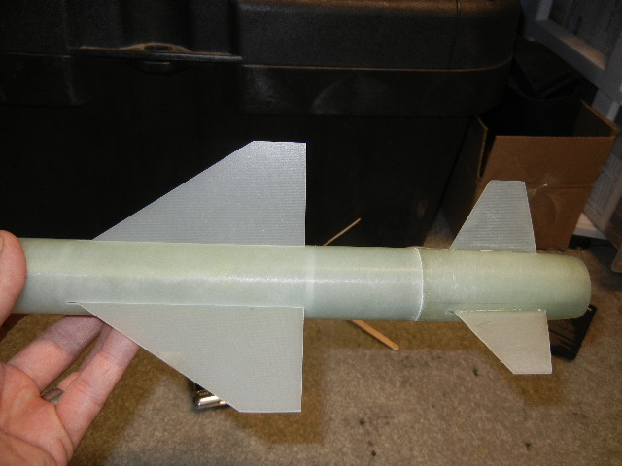

If the boat tail and body tube don’t have a nice flush fit, here is a little trick:
While pushing the tubes together, twist back and forth. You will see fiberglass powder at the seams. The two tubes rubbing against each other will form a nice clean fit. Keep twisting back and forth until you are happy with the fit.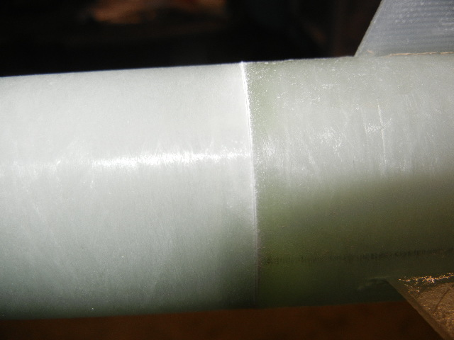
Using a door frame or straight edge, draw a line on the body tube on the fin slot. Extend the line all the way to the aft end of the tube.
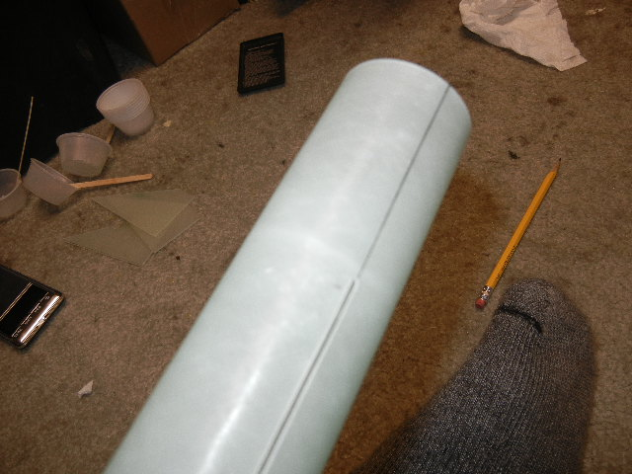

Without any glue, slide the body tube onto the boat tail and align the lower fins with the lines you just made. Extend the lines to match the lower fins.
These lines will be your guide for proper alignment of the upper fins. Take care with this step. It will make the upper fin alignment easier.
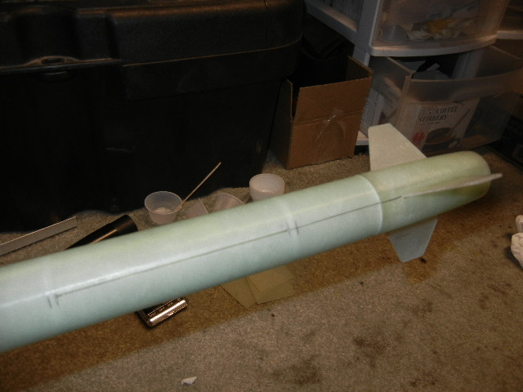
Now you are ready to join the body tube and the motor mount/boat tail assembly.
Prep the assembly, by placing the shock cord inside the motor mount tube. This is to keep any and all epoxy off the cord during motor mount installation.
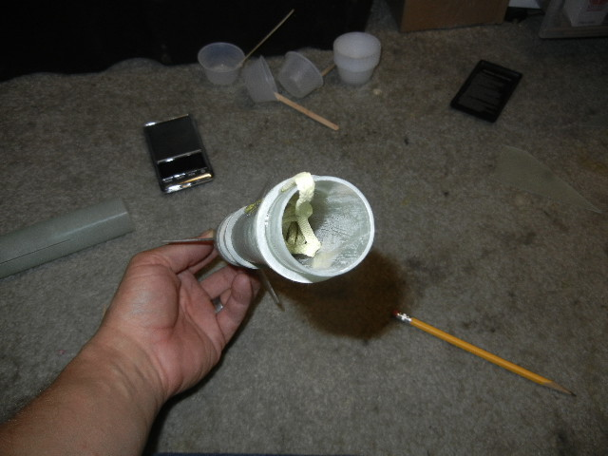

Next, mix up some epoxy and place a liberal amount around the aft end of the body tube. As you slide the motor mount assembly into position, the epoxy will get “pushed” into place with the forward centering ring. Some of the epoxy will be left behind near the fin slots. Keep the slots free of epoxy as best as you can. Once the motor mount has been pushed up into position, pull it out just enough to put epoxy around the coupler . Push back into place and line up all the fin alignment marks on the body tube and boat tail.
Stand the rocket upright and allow the epoxy to cure. Wipe off all excess epoxy from body tube now to save time sanding later.
Install the upper fins with a liberal amount of epoxy on the root cord edge of the fins. It is easiest to do the fins one at t time with a straight edge of some sort to keep the fins aligned.
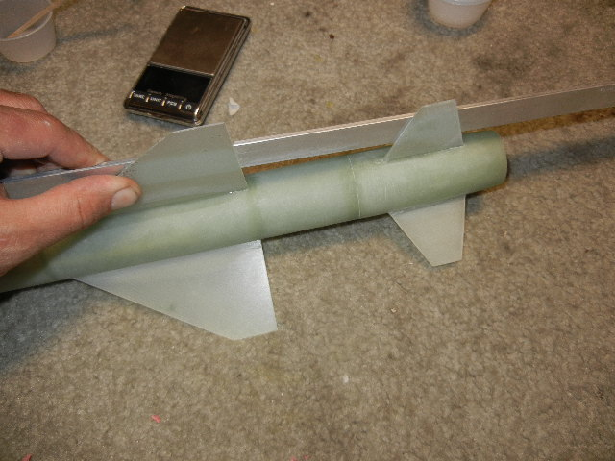
(missing picture of hand missing and clamps holding fin guide…feel free to hold it while the epoxy cures)

Add some external fillets and the booster is complete.

Remember, these fins have no injected internal fillets, external fillets are recommended.

File or sand away a small area around the inside of the nose cone. This will be for the nose cone/shock cord attachment point. I found a small wire brush on the end of a Dremel tool worked perfect.
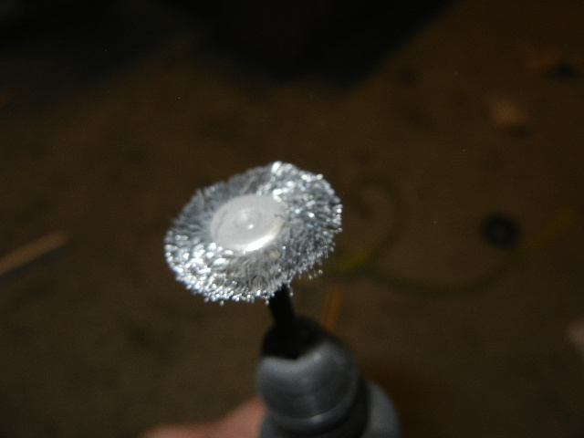

Sand just a thin section to allow for a good bond with the epoxy.
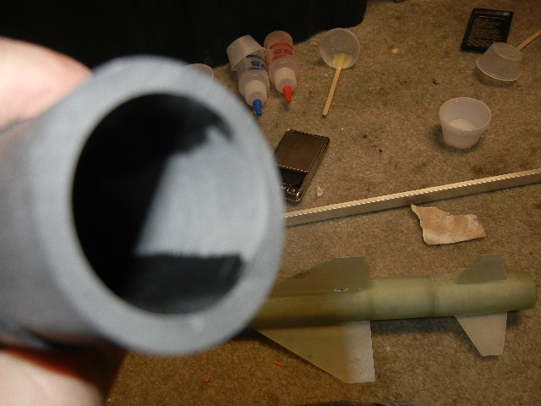

Attach the shock cord into the nose cone and encapsulate it with epoxy.
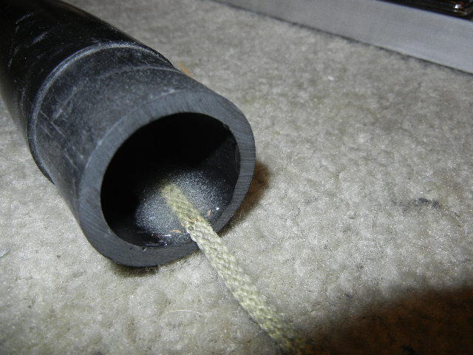

If you want, make the nose removable with a cut off section of cord with a loop like this.
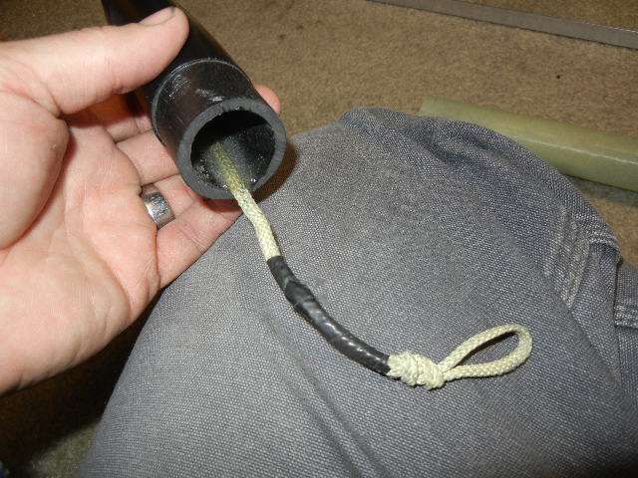
There are other ways to do this as well. Do what works best for your needs.
Last but not least. Add a 1/8’’ vent hole at the center point of the body tube.

Install parachute. You are ready to claw up the sky….Mini Wildman Style!!

