
Demon 98 Build Instructions
Parts list:

Kit:
Nosecone (w/phenolic tip, welded eyebolt)
Vent Band
Long Coupler (av-bay)
Aluminum bulkhead (x2)
Body Tube
Short Coupler (boattail)
Centering Ring (x1)
Motor Mount Tube
Boattail
Fins (x3)
AeroPack Motor Retainer
Necessary Parts:
Shock cord (x2, drogue & main)
Parachute (drogue & main)
Epoxy
Rail Buttons
¼”-20 All-Thread
Altimeters & Sled

Optional Parts:
Nomex® Chute-Protector
Stainless Steel Quicklinks
Stainless Steel Eye-bolts

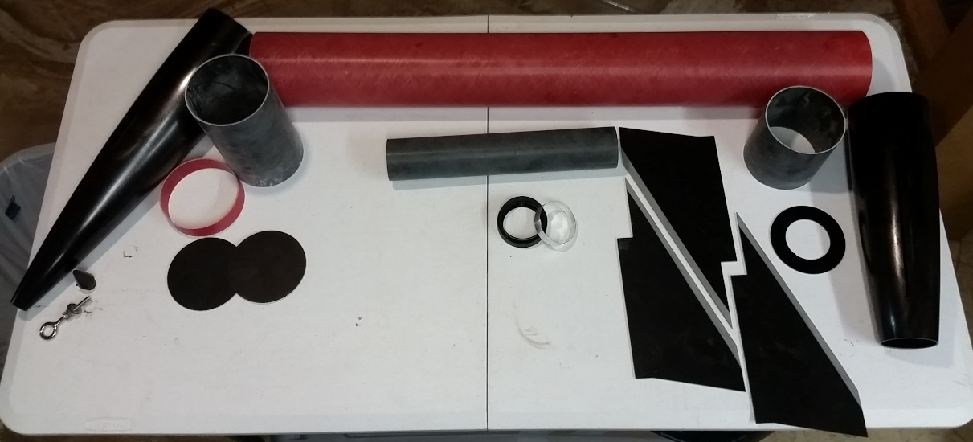
Demon 98 kit

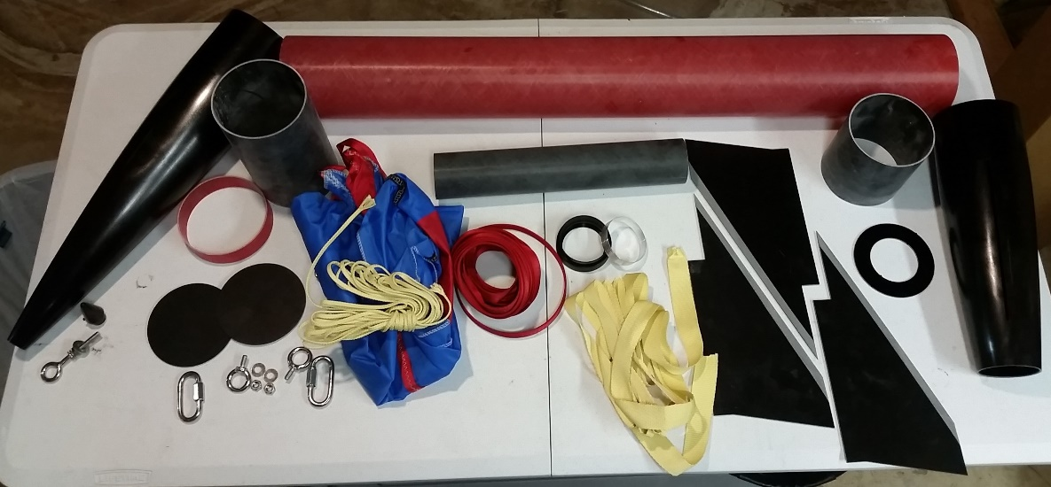
Demon 98 kit & parts

Step 1: Prepare all parts
- Wash all fiberglass
All fiberglass parts should be washed in a mild detergent, like dish soap. This will clean off all the mold-release agent and dust from the cuts. Simply fill a sink or bucket with soapy water and wash the parts like you would wash the dishes. Rinse with clean water and dry them off.
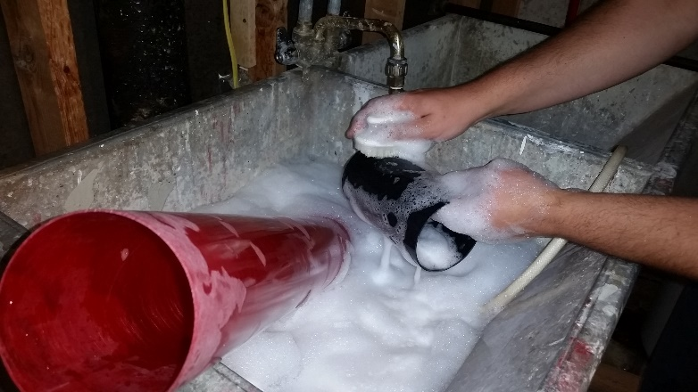

- Sand Motor Mount tube
All fiberglass surfaces that will be bonded should be sanded using 60 or 80 grit sandpaper to create a rough surface area for the epoxy to adhere to. The entire motor mount tube should be sanded since the fins, harness, centering rings, and internal fillets will all be bonded to it.
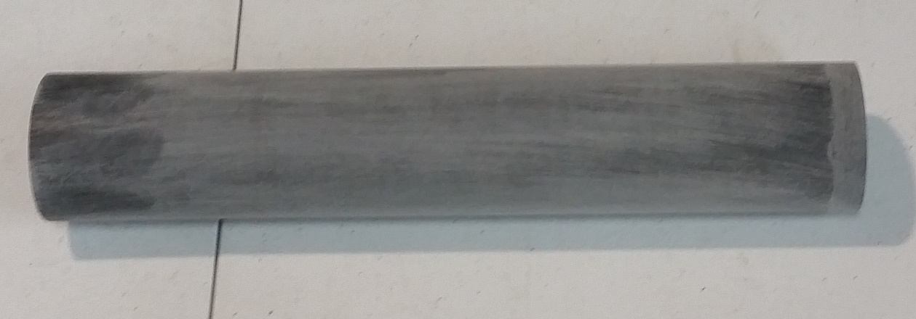

- Sand Centering Ring
The centering ring should be sanded on both sides since internal fillets will bond to it.
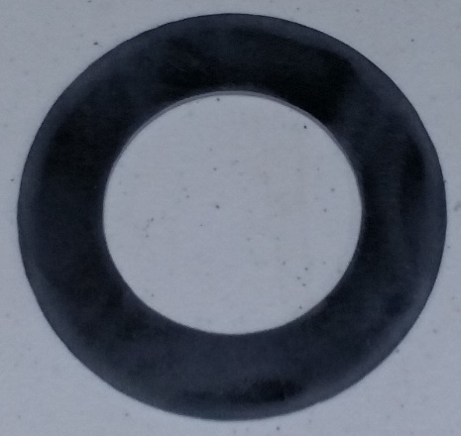

- Sand Root Edge of fins
The “root edge” of the fin is the bottom edge of the fin that will bond to the motor mount. Sand it using 60 or 80 grit sandpaper, again, for bonding. This is also a good time to sand the bottom ½” or so on both sides of the fin which will be bonded with the internal and external fillets.
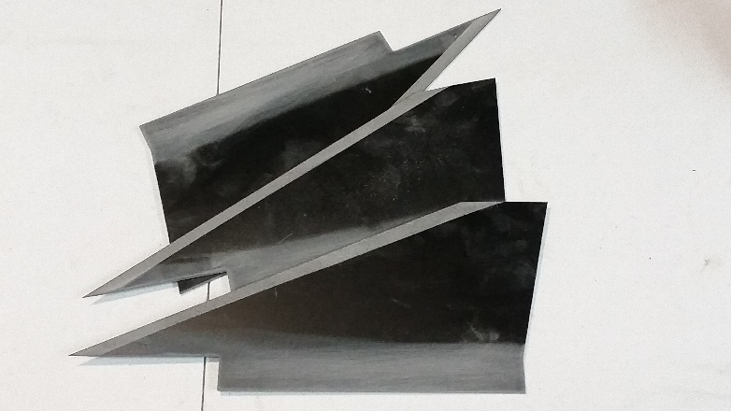

- Sand area around fin slots, inside and out
Since the fillets will adhere to the boattail just around the fin slots, now is the best time to sand around them easily. Sand about ½” on each side of the fin slot both on the outside and on the inside of the airframe. Again, use 60 or 80 grit sandpaper as this is for bonding purposes.
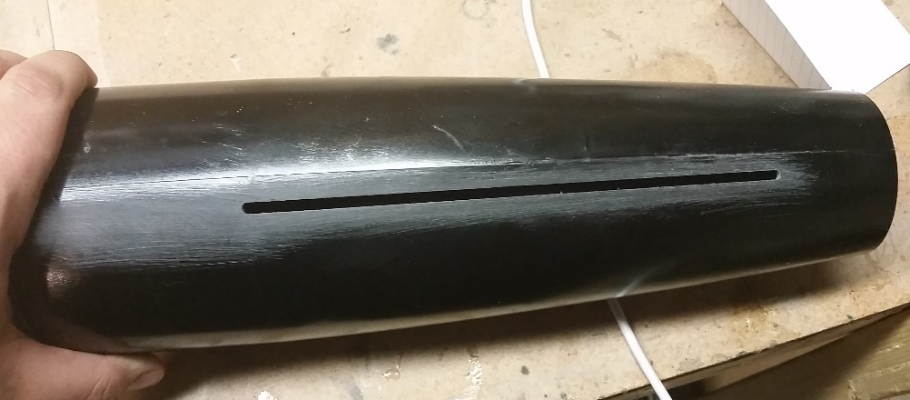

- Sand the Short Coupler, inside top of boattail, inside bottom of body tube
The entire exterior of the short coupler should be sanded, as it will be bonded both with the boattail and the body tube. Also sand where this coupler will fit into the top of the boattail and the bottom of the body tube. Finally, sand about 1” up on the inside of the coupler; this is where the centering ring will bond. Again, use 60-80 grit sandpaper. Be careful not to sand too far up the body tube as you don’t want to leave marks in the transparent tube that won’t be covered by the coupler.
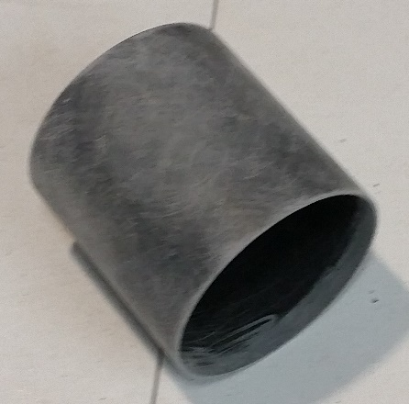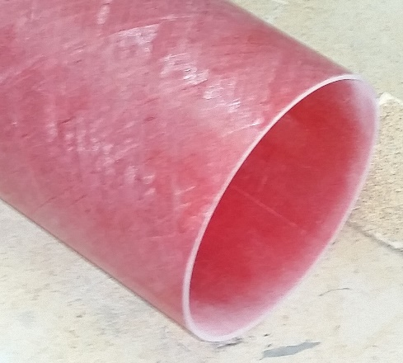
- Dry-fit pieces, sand until fit
Now that all the bonding surfaces have been sanded, it’s time to get everything ready for the build. Test fit the pieces, and sand accordingly if things don’t fit. A little tightness is okay as is a little looseness. The parts should fit so that you can move them around as you build, but not so loose that they will slip around once you’ve set the epoxy. Now is also the point when you’ll want to make sure all your pieces are squared off. Sometimes the manufacturing process leaves little tabs on the tubes that you should square off, for example. After all this sanding, it’s a good idea to wipe down all the parts with a damp cloth/paper towel to remove all the dust. Once the pieces all dry-fit together, you’re ready to start building.

- Mark Aft (short) coupler
The short coupler will connect the boattail to the airframe. Use a ruler to mark halfway up the coupler (4” coupler, mark should be 2”)
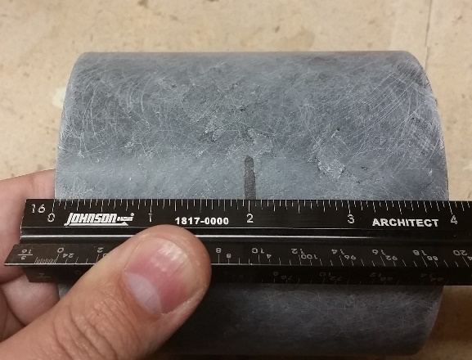

- Mark Av-Bay Coupler for Vent Holes
It’s a good idea to mark the Av-Bay coupler with lines so you can easily drill sheer pin holes and Vent Holes. Usually this is done by inserting the coupler into the aft end of the body tube and using the fin slots. Since we have a boattail, we can instead drop the coupler over the back end of the boattail and mark where the slots are. Then, using angle iron or an angled carpenter’s scale, mark three lines. This ensures all holes will be 120° apart.
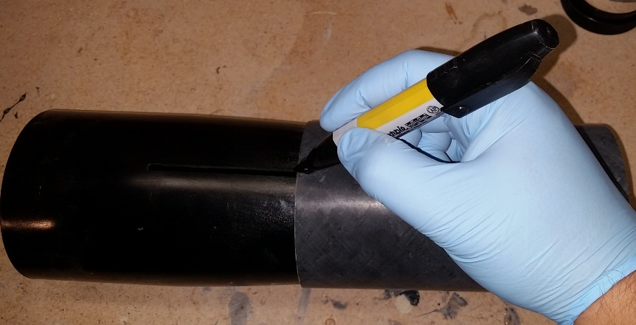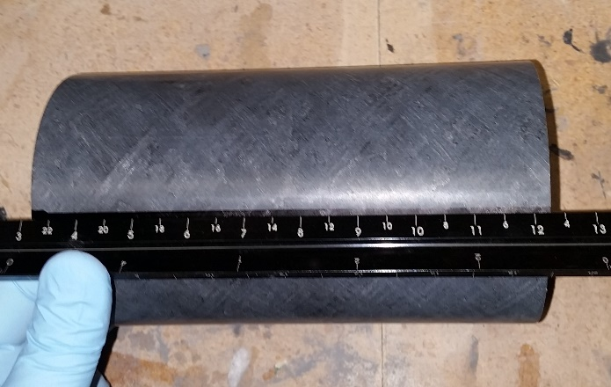

Step 2: Motor Mount
- Mark Motor Mount Tube for fin location
You’ll need to mark the location of the fins so that when you attach the shock cord/harness, you don’t interfere with the fins bonding to the motor mount. Dry-ft the motor mount into the aft of the airframe and use a marker, pencil, or other implement to mark a line through the fin slots. You can use a razor to score a light line if you wish, or pull the tip out of a marker. Whatever you can get in the slot is good…
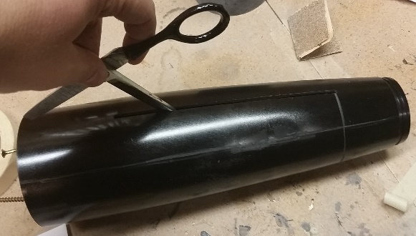

- Cut Y-harness to length
Make a loop of Kevlar strap long enough to go on the motor mount, up to the top of the airframe and back down, with a little extra. Be sure to measure with the boattail since the motor mount will be inside.
Tie a loop (overhand knot) at the top of the airframe and leave two Kevlar leads that reach down to be epoxied onto the motor mount. Cut the strap to the right length. When attaching this later, be sure that the loop is accessible at the top. Having the knot right at the top of the airframe is best.
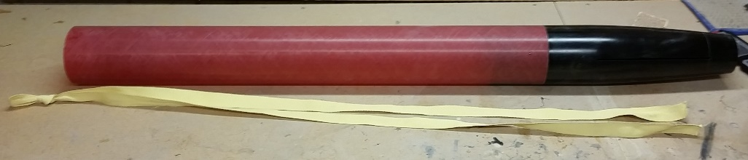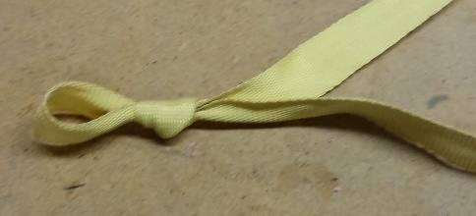

- Notch Top Centering Ring
The Top Centering Ring will seat over the shock cord/harness, so you’ll need to file notches so that the Kevlar strap can fit under the CR and onto the motor mount tube.
Lay the Kevlar strap over the CR and mark where you need to file, and file notches just big enough for the Kevlar. Then, test fit the CR on the tube with the Kevlar to be sure the notch is big enough (cord should be able to move, but not loose). You can do them 180° apart, but you’ll have to be careful to avoid interfering with fins later. You can also file notches 120° apart, leaving more room for fins later.

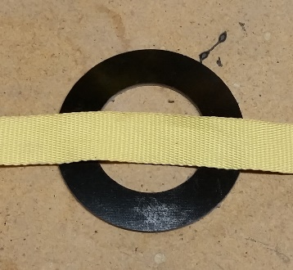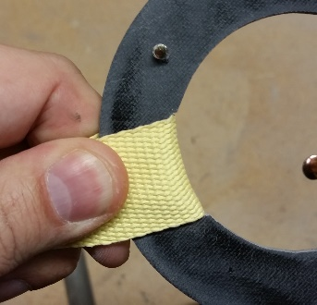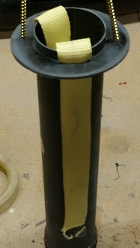

- Attach Aeropack retainer
The Aeropack retainer will serve as both motor retention and bottom centering ring. Since this is thin-wall fiberglass, your kit includes a thin metal band to make the Aeropack fit tightly. First, bond the metal ring to the motor mount. Then, bond the Aeropack retainer to the metal band. Set aside to cure.
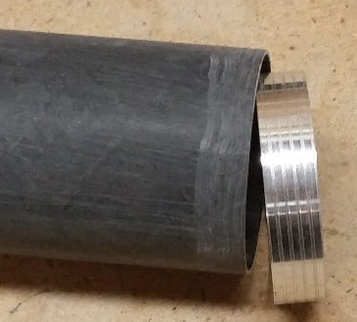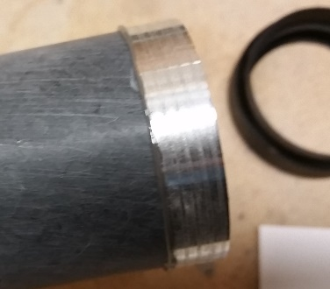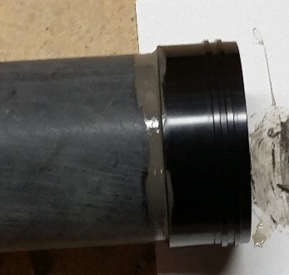
- DO NOT attach centering ring
Do not attach the centering ring yet. You’ll need to access the forward-end of the boattail to make internal fillets later. However, you’ll need to be able to put it on and take it off. Drive two screws partly into the ring to hold it with, and they can be removed later.
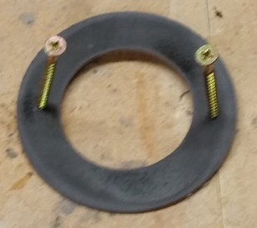
- Attach Y-harness
Make sure that the knot at the top pulls evenly on both attachment points and reaches the top of the airframe so you have access to it later.
Use masking tape to set a boundary for the epoxy on the harness attachment point ⁽¹⁾. I used 1” masking tape to set a fwd boundary that will come in handy later when affixing the centering ring.
Mix a batch of epoxy and lay some under the harness ⁽²⁾. Then, press the Kevlar into the epoxy ⁽³⁾, and put more epoxy over the top ⁽⁴⁾. The entire cord should be encased in epoxy below the top CR. Be sure to NOT bond the top centering ring to the motor mount at this point.
1) 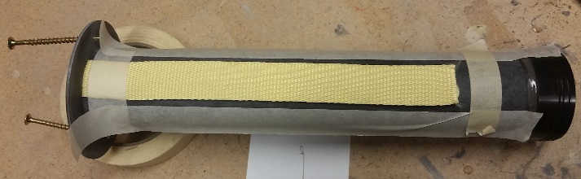 2) 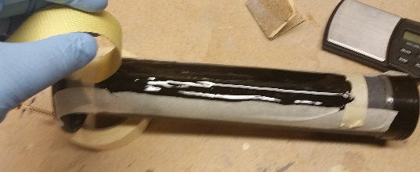

3) 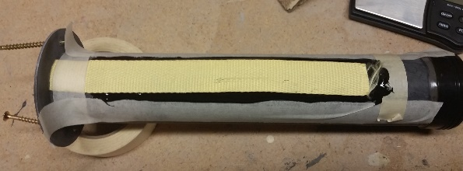 4) 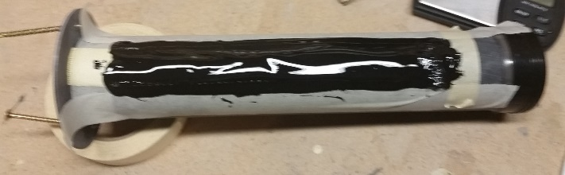
After the epoxy sets up a little (and before it cures completely!), pull the tape off ⁽⁵⁾. Repeat for the 2nd strap. Finally, tuck the harness inside the motor tube, set aside and let the epoxy set.
5) 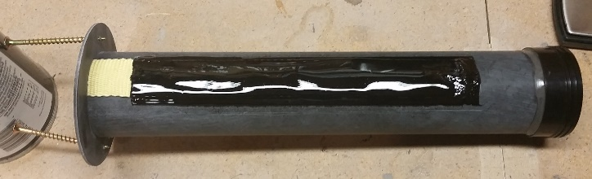

Step 3: Fins
- Bond the short coupler into the boattail
To ensure proper alignment of fins, you’ll need to have the top centering ring in place which requires the coupler to be in the boattail. Be sure to scuff up the inside of the boattail liberally. Then, liberally spread epoxy on the inside of the boattail (all the way around the inside) and slide the coupler into place. You’ll want to ensure that it is straight after its in place by sliding the body tube over it and aligning the coupler before the epoxy sets; once you’re sure the coupler is straight, take the body tube off and set the boattail aside until the coupler is cured.
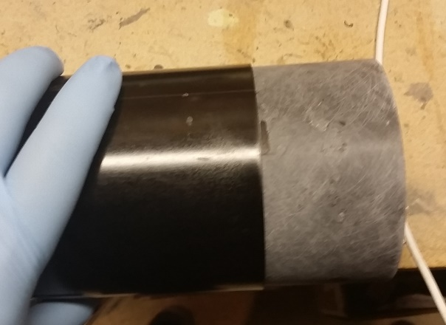

- Insert motor mount (with CR in place for proper fin placement)
The fins will be epoxied directly to the motor mount tube, so the first thing is to place the motor mount, with retainer into the boattail. Stuff the shock cord into the top of the motor mount tube to keep it out of the way. Be sure to align the motor mount so that the shock cord is not in line with the fin slots so that the fins can seat directly and flatly on the motor mount tube. The AeroPack retainer fits very snugly into the bottom of the boattail; you should be able to push the boattail onto the retainer until it hits the first lip of the retainer.
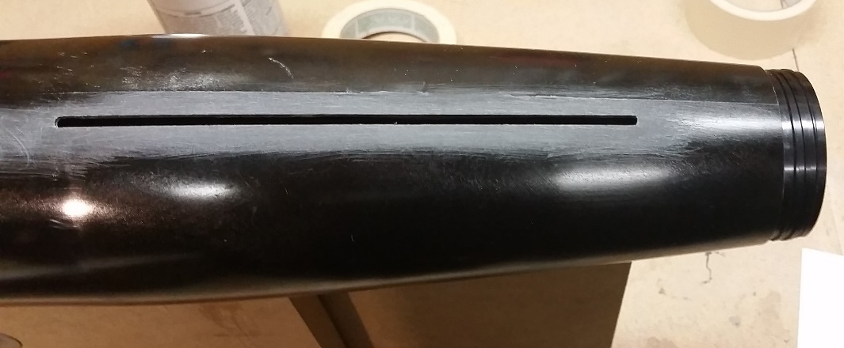

- Align Motor mount with CR
Make sure the motor mount is aligned properly by sliding the centering ring in place, but NOT epoxied in place. With a 4” tube, you should still be able to maneuver the CR using the screws.
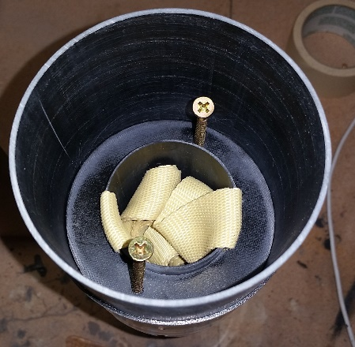
- There’s more than one way to attach the fins; some people do one at a time, some people do all three using a fin-alignment jig. My fin alignment jig required me to have the body tube in place, but it is NOT epoxied in place (I’ll remove it later for internal fillets). I taped it in place to ensure that the boattail was at the proper angle while attaching my fins.

First, mix a batch of epoxy (JB Weld pictured) then “butter” the root edge of a fin. You can smear a bit on the sides of the fin at the root edge. This will be helpful in sealing the fin slot for internal fillets.
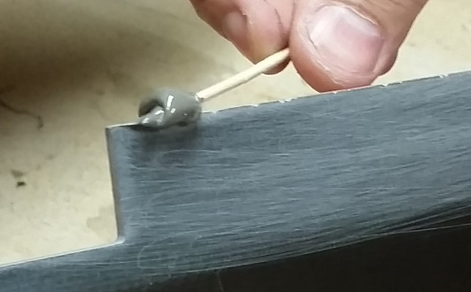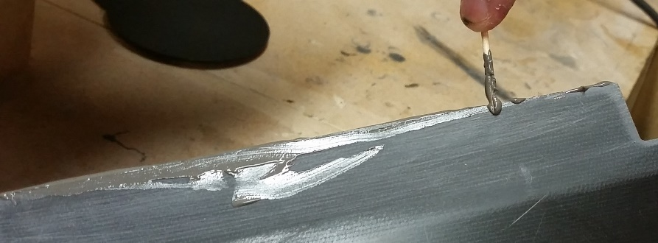

Next, slide the fin into the slot and press it down against the motor mount tube. Be sure it is completely in place against the motor tube. If you’re doing one fin at a time, let this set until the epoxy is completely cured. Using a fin alignment jig while the epoxy sets is important; you want to be sure that each fin stays aligned precisely and doesn’t slide around later when you’re attaching other fins.

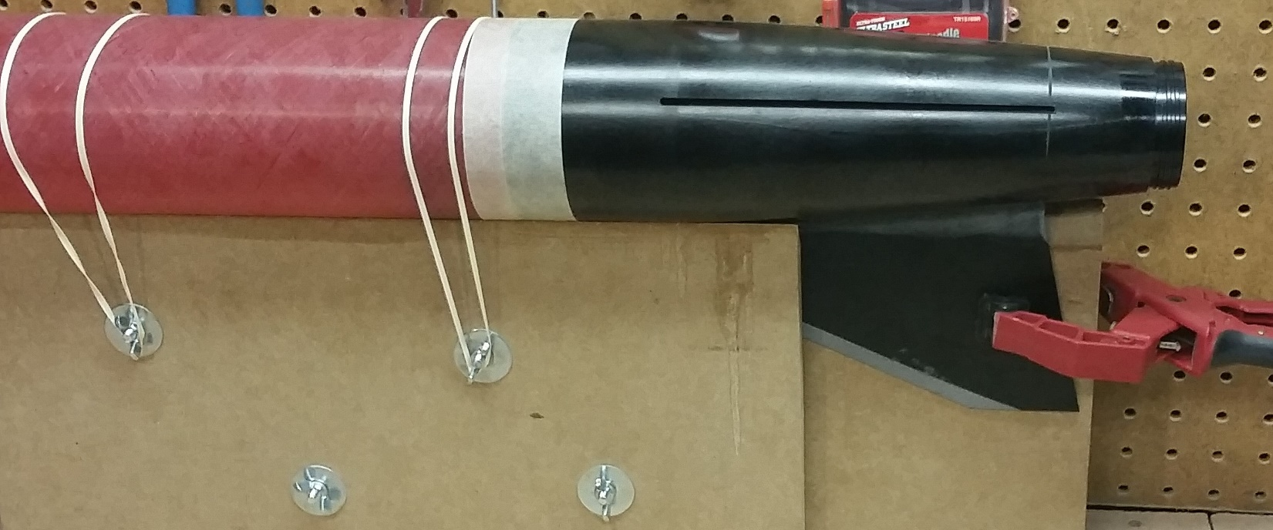

If you’re doing all three fins, place the fins then slide your jig into place. Be sure the jig doesn’t get epoxied to the airframe by excess epoxy!

Step 4: Internal Fillets
- First, pull the centering ring out of the airframe so that you can access the space between the motor mount and airframe
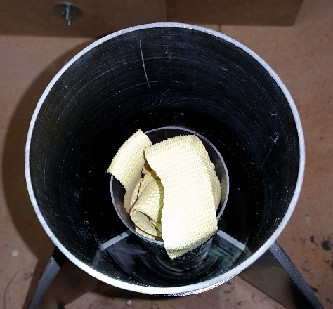

- Mix enough epoxy for a set of two internal fillets (RocketPoxy pictured).
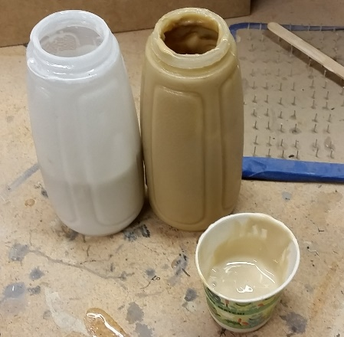

- Using a dowel rod long enough, gather up a bead of epoxy and spread it along the fin root edge. Repeat as many times as necessary to get a good internal fillet.

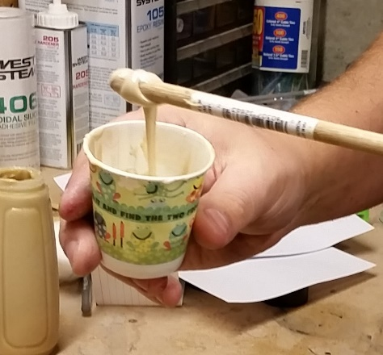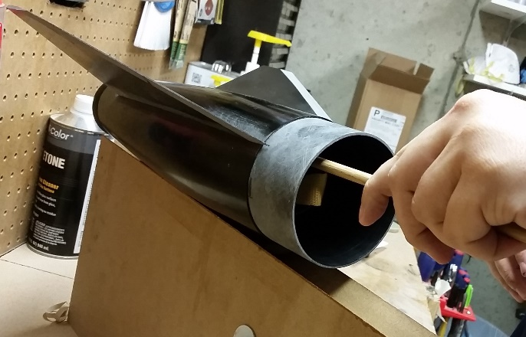

- Set aside and wait for the epoxy to cure, then rotate repeat.

Step 5: Attach Centering Ring and Airframe
With the fins in place and internal fillets done, we can now permanently place the Centering Ring and Airframe body tube.
- Place the Centering Ring back in place. Push it down as far as you can, it should be stopped by the y-harness attachments
- Tack it in place with a few drops of CA then remove the screws
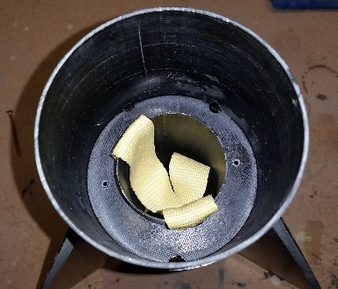
- Mix some epoxy and pour a small bead around the outside edge of the CR against the coupler. Let it run around the edge until even. If some drips through the screw holes, no big deal, it’s just a couple drops; you may want to be careful, though, to make sure it doesn’t come out of the aft end and get epoxy on the exterior of the motor retainer.
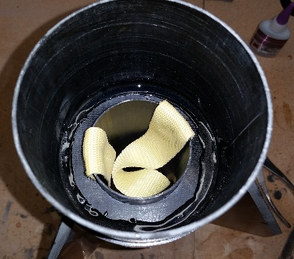
- Next, mix some epoxy and smear it on the inside the airframe all the way around. Since the tub is transparent, it’s a good idea to keep this an even coat, and all the way around.
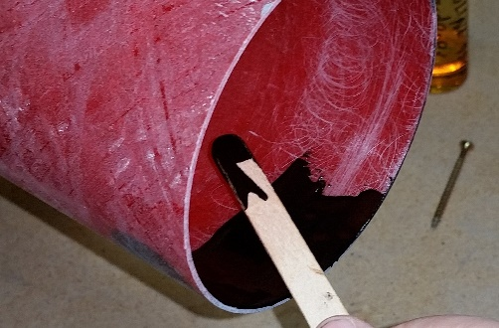
- Slide the boattail assembly into the airframe, twist while pushing it in to ensure complete epoxy coverage. Once it’s pushed all the way in, continue twisting until you have a very even coat of epoxy all the way around the airframe and coupler.
- Stand the rocket upright while the epoxy cures.
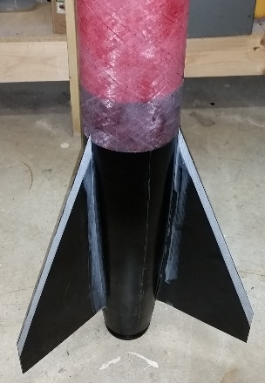

Step 6: External Fillets
- First, sand the area to be bonded using 60 or 80 grit sandpaper. This is easily done by bending a piece of sandpaper (not folding), holding it in the corner and scuffing back and forth.
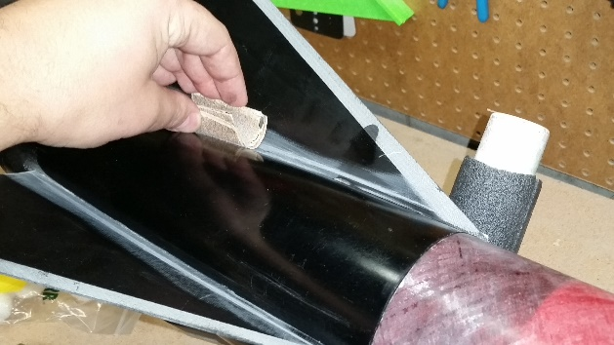

- Be sure to clean off all the dust using acetone or other cleaner.
- Tape off the area of the fillet. You can mark the lines of the fillet by rubbing the fillet tool (I used a small chunk of 1” PVC) along the airframe. If you color it heavily with a marker beforehand, it should leave enough of a line to see where the fillet will be.
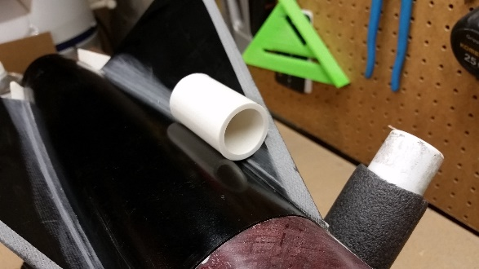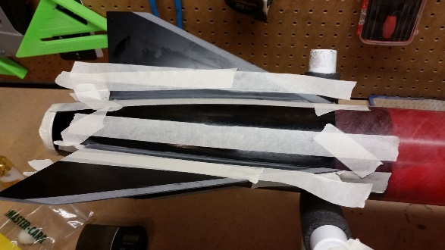

- Mix a batch of epoxy and pour it into the fillet area. Let it settle. Depending on the type of epoxy you use, you’ll want to let it set up a bit before you pull the fillet.
I used 32.5g of Proline 4500 (27.5g Resin, 5g hardener) and let it set for about 45 minutes.
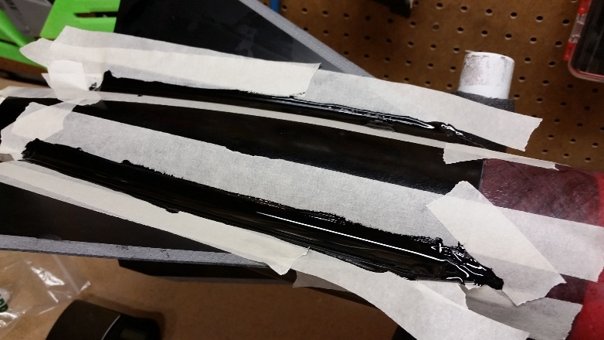

- Pull the fillet into shape. Starting from one end of the fin, pull straight along the fillet without stopping, allowing the excess epoxy to flow out onto the tape
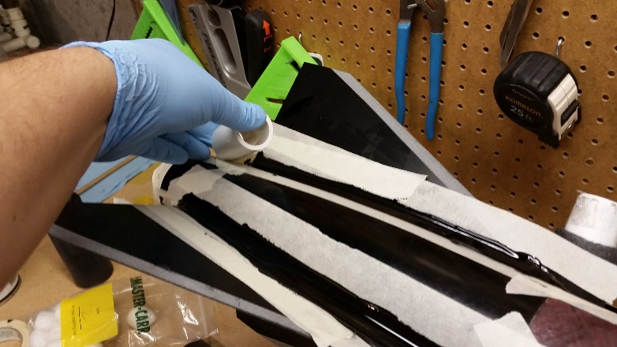
- As soon as you’ve pulled the fillet into shape, pull the tape off right away. Be sure to pull the tape at a sharp angle so as not to leave drips.

- Set aside until the epoxy fillet cures completely. Rotate and repeat for each set of fins.

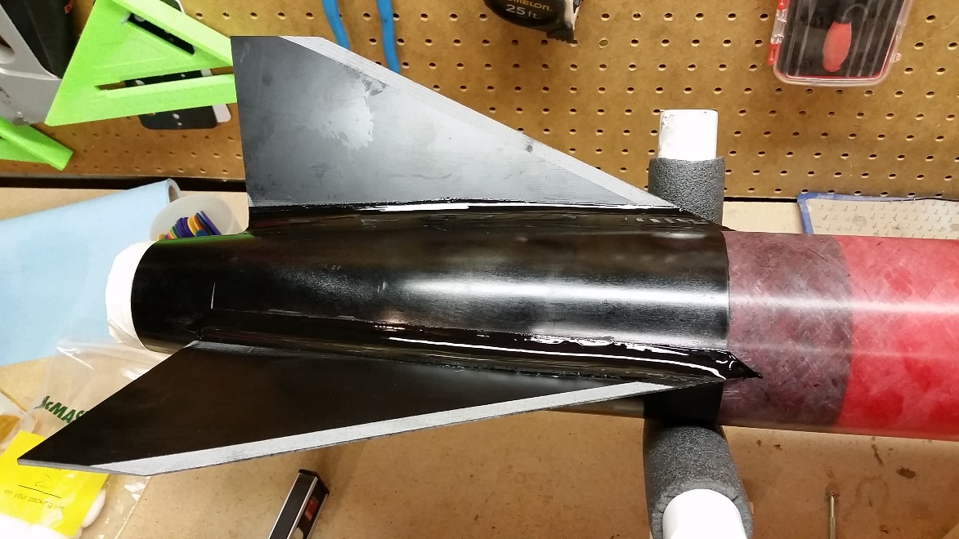

Step 7: Airframe Finishes
Rail Buttons
- The aft rail button should be located just above the boattail at the bottom of the airframe tube. The forward rail button placement should be located about 10” forward of the aft rail button.
- Drill holes using a 1/8” bit for standard 1010 rail buttons (which use 8-32 screws). Placing masking tape over the spot to be drilled keeps the holes a little cleaner.
- Screw the buttons into the holes, allow them to self-tap the holes. You’ll be removing the buttons for paint, so do not epoxy or glue them in. Even after paint, epoxy or glue on the buttons is not necessary for rail buttons.
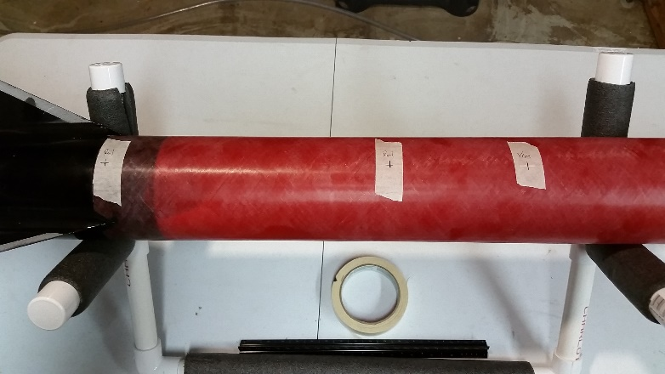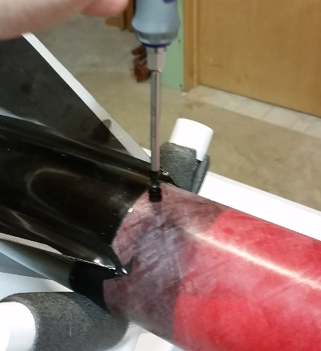

Vent Hole
- Measure 18” down from the top of the airframe, and drill a 1/8” vent hole in the airframe.

Step 8: HED (Head-End Deployment) Av-Bay & Nosecone
- First, make sure your coupler will slide into the nosecone without too much difficulty. This might require some light wet sanding of the coupler. Sand and try fitting it until you can get the coupler into the nosecone without too much effort and can get it out by hand. After you sand, be sure to wash the nosecone to get all the dust out; a clean nosecone slides better…
- Insert the Av-Bay coupler WITH an aluminum bulkhead into the nosecone. It’s critical that you have a bulkhead for proper alignment.
- Then, slide the vent band onto the coupler and mark it’s place by wrapping masking tape precisely along the bottom edge of the vent band.
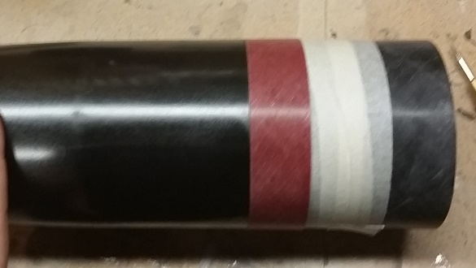
- Pull the coupler and vent band out
- Mark the location of the top of the vent band on the with a pencil. This is a good time to mark which side of the coupler goes into the nosecone.
- Slide the vent band off the coupler
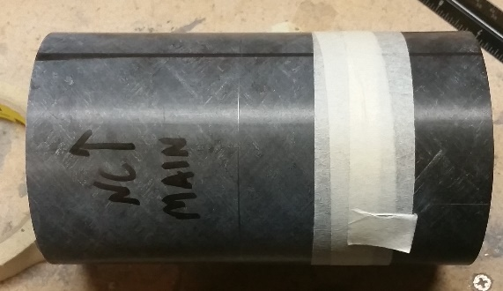

- Sand/prep the surface of the coupler for bonding with the vent band
- Smear epoxy where the vent band will adhere
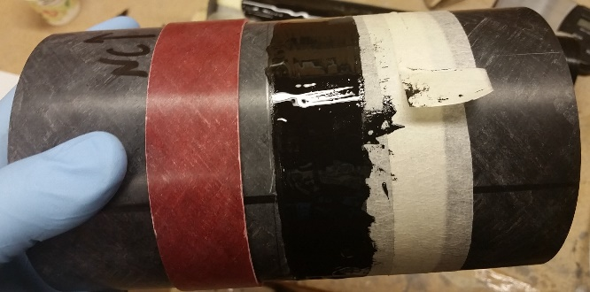

- Twist and slide the vent band into place. Excess epoxy should squeeze out onto the masking tape you placed earlier.
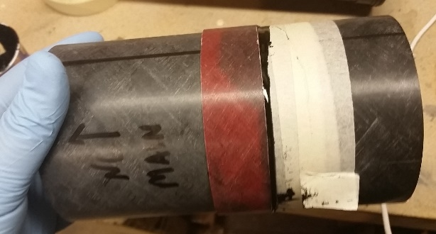
- When the vent band is in place, peel away the masking tape, leaving little to no excess epoxy to wipe away. Then set this aside to cure.
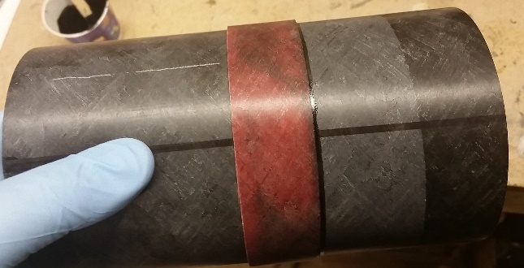

- Drill Vent holes in Av-Bay
Place a piece of masking tape all the way around the vent hole. Along the lines marked at the beginning of the build, mark halfway up the vent hole. Drill 3 11/64” vent holes for the av-bay.
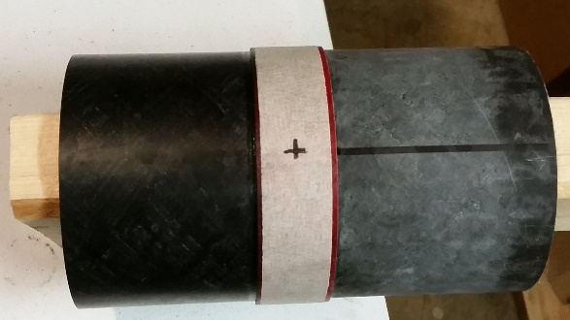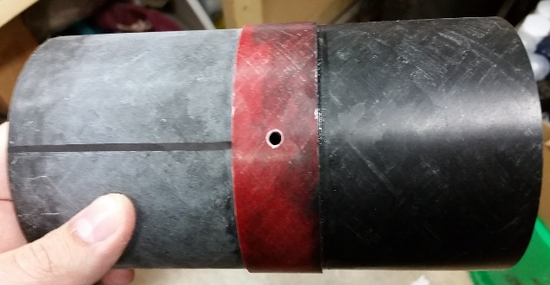

- Drill Sheer Pin holes in nosecone
Place a piece of masking tape around the bottom of the nosecone. Using the lines on the av bay, mark 3 drill holes 1½” from the bottom of the nosecone. Then, rotate the av-bay/coupler 60” (halfway between the marks), and drill the holes for sheer pins. Each hole should be 5/64”. When you drill a hole, place a sheer pin in the hole before moving to the next one. After drilling all the sheer pin holes and vent holes, sand inside the av-bay coupler to clear out the fiberglass strands, and you can use a small file to make sure the vent holes are clear of all fiberglass.
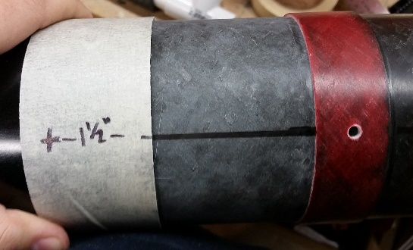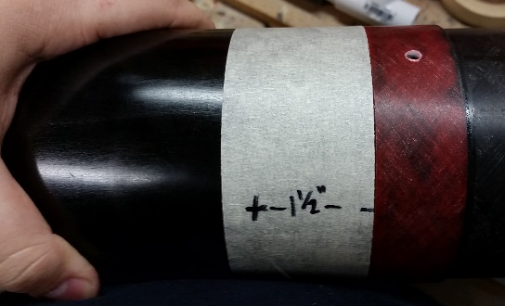

- Make a Key-Mark
With the nosecone sheer pins in place, it’s a good idea to make a key-mark to make alignment easier later. Place a piece of tape over the vent band and nosecone. Use a dremel cutting wheel to cut a very shallow line across both. Remove the tape.
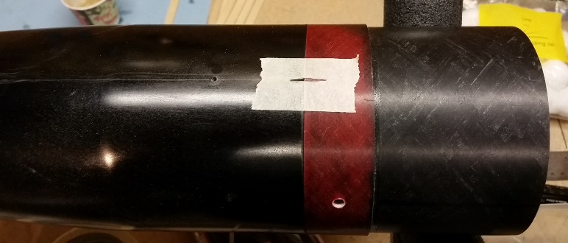

- Build your av-bay
The aluminum bulkheads should have divots machined into them: one on center, and two that are 3” apart, aligned with the center of the bulkhead. Drill ¼” holes through each of these. Use eyebolts in the center holes for harness attachment points, and use the 2 other holes for two ¼”-20 all-threads to hold the av-bay together. Since these holes are 3” apart, they’re a perfect fit for your Missileworks 3D printed sled!

Nosecone
- You’ll need to drill a 1/8” vent hole about 10” from the tip of the nosecone. Since this is a HED kit, the nosecone is acting as a payload bay and therefore needs to be vented.
- Tie one end of the shock cord to the welded eyebolt before attaching the phenolic tip.
- Thread a nut onto the eyebolt, place the washer on top, then slide the threaded-end through the hole at the tip. Screw on the Phenolic tip as tightly as you can.
  - Making a tool to hold the eyebolt is really easy… Get a length of ½” PVC pipe, cut a notch in the end just wide enough for the eyebolt. This way, you can thread the shock cord through the PVC pipe and have grip on the eyebolt to turn it. Keep this tool handy in case you ever need to take off the tip, make a new shock cord, etc.
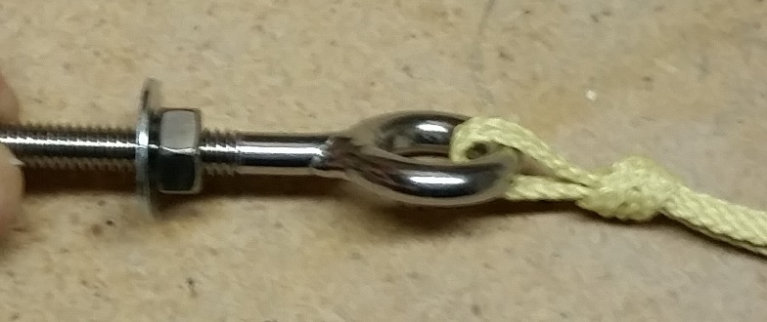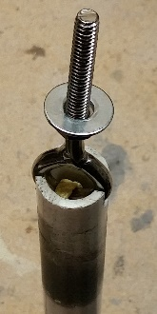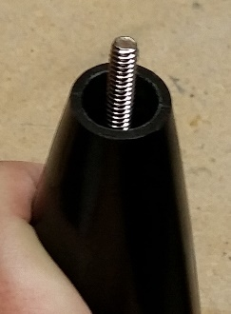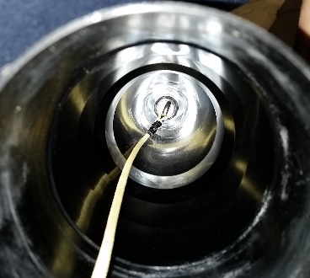

Step 9: Paint
- Remove Rail Buttons prior to paint
Since you’ve simply threaded the rail buttons directly into the airframe, they should be easy to remove. While you’re painting, some paint will get into those holes, and that’s fine. After painting, simply screw the buttons back into the holes, and let them self-thread the painted holes. You’ll find that the painted hole will “grab” the screw quite tightly.
- Mark CP location (or minimum CG location)
The Center of Pressure on the Demon 98 is at 45.6” from the tip of the nosecone. In your paint scheme, you’ll want to include something that clearly marks the CP or the minimum CG location. That way, no matter what motor you use or what other gadgets you end up adding, you’ll always know, on-site, whether your rocket will be stable.
- Paint
Enamel Gloss Clear Coat paint really brings out the shine/candy-apple color of the red tubing. If you want to even out the black, you can just use some black primer before using clear coat over the whole thing. Just a basic enamel flat black primer, wait 30 minutes, then shoot the clear coat, and BAM, done.

Some quick tips…
- As built: 65.15”, CP at 45.6”, 7.5lbs (including chute, harnesses, hardware)
- Recon 40” chute for main, 12” Nomex for wrap
- 12” Drogue chute, 6” Nomex for wrap
- 0.8g BP for HED Main chute, 3.5g BP for Drogue

